ABDUL REHMAN ASAD
24K-0722
BCS-5A
CN ASSIGNMENT 2
Random seed: 722

Task 3: Approach and Implementation
Approach. GBN and SR are implemented from scratch in Python (gbn_sr.py; the Task 4 experiments are run by run_experiments.py) as a discrete-event simulation. Both sender/receiver pairs communicate only through a simulated unreliable channel that independently applies loss, corruption and extra delay to data packets and ACKs. Link parameters follow the scenario: R = 2 Mbps, L = 8000 bits (4 ms transmission time) and RTT = 500 ms (250 ms one-way); the timeout is 600 ms. Every send, receive, ACK, loss, corruption, timeout and retransmission is logged.
- Go-Back-N: sliding window with base and nextseqnum; cumulative ACKs (value = next expected packet); a single timer for the oldest unACKed packet; on timeout all outstanding packets base..nextseqnum−1 are resent. The receiver keeps expectedseqnum, delivers only the in-order packet and discards out-of-order packets, re-ACKing the last in-order one.
- Selective Repeat: sender and receiver windows (base, nextseqnum, rcv_base); individual ACKs; a timer per packet; the receiver buffers out-of-order packets, delivers in order as gaps fill and slides rcv_base; only the timed-out packet is retransmitted.
- Error model: corruption flips one bit; a 16-bit Internet checksum detects it and the packet/ACK is discarded (a corrupted data packet gets no ACK, so the sender recovers by timeout). Sequence numbers wrap modulo 2^k; an absolute id is kept internally to tell wrap-around cycles apart. SR requires N ≤ 2^(k−1) and GBN N ≤ 2^k −1, enforced at start-up.
- Assumptions: ACKs have negligible transmission time; extra delay is uniform in 0.5–1.5× timeout; completion time is when the sender receives the final ACK. Results are outcomes of this model and seed 722, not measurements of a real satellite link.

Task 4: Experiments and Results
Each run sends 200 packets with N = 4 and k = 3 (seed 722). A: reliable channel; B: loss 0.10; C: loss 0.05, corruption 0.05, delay 0.10 (all applied to data and ACKs).
Case | Protocol | Transmissions | Retransmissions | Delivered | Completion time (ms) | Throughput (kbps)
A: Reliable | GBN | 200 | 0 | 200 | 25,212 | 63.46
A: Reliable | SR | 200 | 0 | 200 | 25,212 | 63.46
B: Loss 0.10 | GBN | 288 | 88 | 200 | 43,588 | 36.71
B: Loss 0.10 | SR | 248 | 48 | 200 | 41,604 | 38.46
C: Mixed errors | GBN | 331 | 131 | 200 | 54,684 | 29.26
C: Mixed errors | SR | 281 | 81 | 200 | 46,342.9 | 34.53
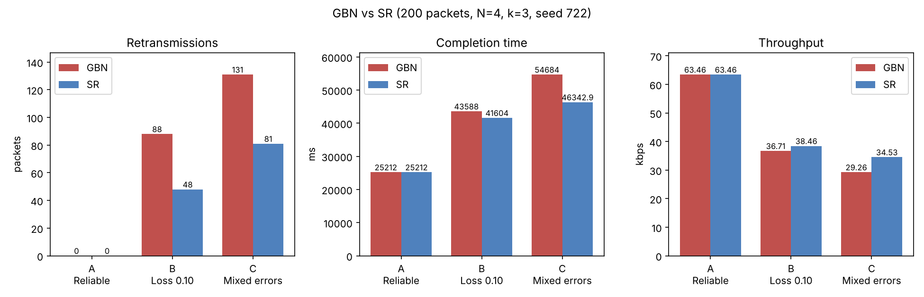
Comparison. On the reliable channel both protocols behave identically (0 retransmissions, 25,212 ms). Under loss, GBN made 88 retransmissions against 48 for SR, and under mixed errors 131 against 81. This is because GBN resends every outstanding packet after a timeout, including ones the receiver had already received but discarded as out-of-order, whereas SR buffers them and resends only the packet that is actually missing. The saved retransmissions give SR a shorter completion time and higher throughput (38.46 vs 36.71 kbps in B; 34.53 vs 29.26 kbps in C), at the cost of receiver buffering and per-packet timers.

Conclusion
Both implementations deliver all 200 packets correctly and in order under every tested channel condition. When errors occur, Selective Repeat avoids unnecessary retransmissions and achieves lower completion time and higher throughput than Go-Back-N, which makes it the better fit for the long-delay, lossy satellite link; GBN remains simpler (no receiver buffer, one timer). The conclusions hold for this simulator model and seed.

